Engaging Storytellers and Generating Stories
PART 1: PERSONAL INTERACTIONS
Conversations
Nothing beats genuine face-to-face for the storyteller voice. And receiving a personal request from a staff member to share their story, knowing it will be heard, valued and responded to is a great motivator for storytellers. Look for opportune moments, the point at which people may want to provide feedback and make it easy for them to do so. This might be when they are looking for an opportunity to say thank you or when they might want to find a way to suggest what could be done better.
Care Opinion offers training on how to assist storytellers to share their stories, part of which includes how to ‘frame the ask’ and engage storytellers in this way. It is perfect for frontline staff, including volunteers, concierge staff and clinicians.
We understand that volunteers and staff play a vital role in encouraging and collecting storyteller feedback in health, community and aged care services. To support this, Care Opinion has developed a comprehensive guide for volunteers and staff to utilize when assisting storytelling on the Care Opinion platform. You may find it useful to help engage storytellers who are generally more averse to providing feedback or to train new staff and volunteers and explore new options of assisting storytelling in your service.
Evaluation of programs and service development is an often-missed opportunity for engaging with storytellers is during the building and development of new services, such as new facilities, programs and initiatives.
For example, ask storytellers to share the stories of their experiences where they compare the experience with the new program/facility with the original one can be used in the evaluation of the program/initiative and/or as a case for its continued funding/operation. Another is for staff who work in the community to let their patients and clients know that their feedback on the experience is valued. It is important to make them aware of the option to share their story at the beginning of the service delivery, with the message reinforced that their story can be shared at any point. This helps storytellers to be aware early in the piece as they often then think about this over the course of receiving care,

particularly when it is care received over multiple occasions or the service supports or enriches the lives of patients, clients and their carers and loved ones. Examples include respite care, rehabilitation services and wellbeing activities such as day trips for residents of aged care facilities. If you wish to discuss these ideas in more detail, please reach your support lead.
PART 2: Promoting and raising awareness of the platform
Promotional materials
People won’t share their stories if they don’t know about the platform or that you would like them to do so. We have a variety of promotional materials (both standard and that can be co-branded) that you can use to draw your storytellers’ attention to the platform including but not limited to:
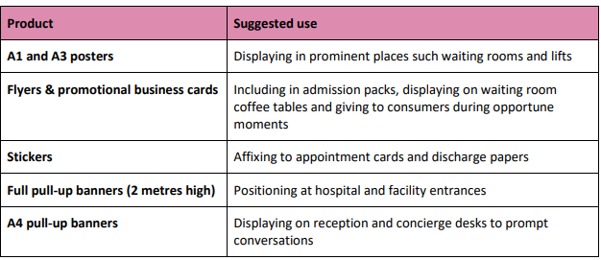
Website presence
The inclusion of a Care Opinion presence on subscribing services’ websites is critical to raising awareness of the Care Opinion service and to enable storytellers to easily submit their feedback (stories). You can easily promote Care Opinion online, add one of our widgets onto your website homepage. We have a selection of different widgets that include 'Latest Stories', 'Tell your Story’ or what about embedding the Care Opinion video so people can watch how Care Opinion works?

Social media
With social media so prevalent, storytellers often look to social media platforms to hear the latest news and information about their service. Care Opinion provides suggested content and imagery suitable for Bluesky, Facebook and Instagram.
Social media is also an opportunity to show storytellers that you value their stories and how you use them by:
• sharing positive stories that are positive, showing pictures of relevant staff where possible • sharing stories where a change has been made from a ‘you said, we did’ perspective.
For assistance and inspiration in using social media to engage with your storytellers around their experiences, contact our Communications Lead @ kellyt@imaginecitizens.ca.
Electronic promotion
To support messaging delivered during conversations and displayed through hard copy and online material, Care Opinion has a range of digital products that can be embedded in waiting room TVs, iPads and other devices. These include PowerPoint presentations, audio bites and short animated videos about the platform. To access these resources, contact us at info@careopinion.ca.
Invitation links
Invitation links enable you to create a unique pathway to a storytelling page that pre-links the story to your specific service. This can be an organization name, a hospital or even a specific department (e.g. Day Surgery). Invitation links can be created in the back end of platform by any staff member with ‘Responder’ or ‘Administrator’ access to the site.
The functionality enables you to:
• customize the messaging displayed on the storytelling page with a requested feedback focus (telling storytellers that you are particularly interested in hearing specific elements of care or the experience).
• create a QR code from the invitation link which can be saved as an image and added to your promotional material

• track which stories have been told via each invitation link.
For example, you can create a different link for your social media channels, your website and to go out in text messages to patient’s post-discharge. You can then track which stories were told via each link to understand what communication mechanism best reaches your storytellers. For more invitation on creating invitation links, visit our website or contact our Client Liaison Lead.

